Task 7: Docker

Launched EC2 Instance:

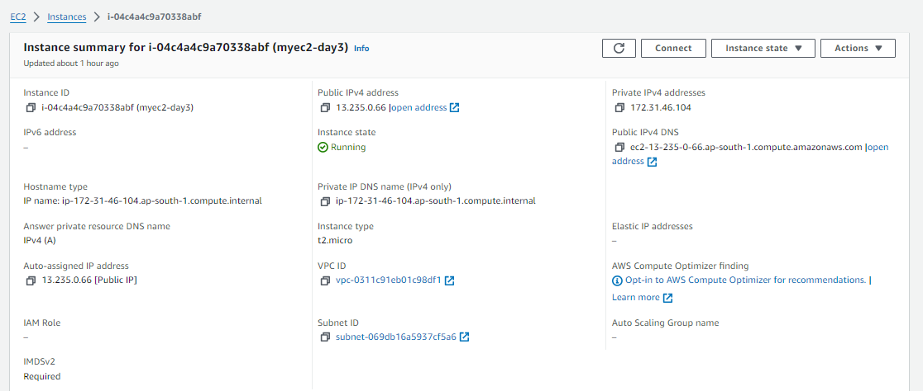

Connected to EC2 SSH Session:

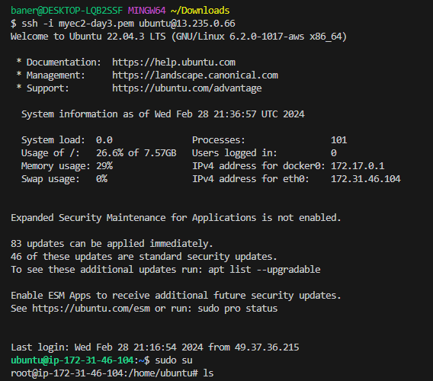

Install docker packages in EC2 machine:

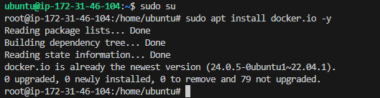

Docker engine status check:

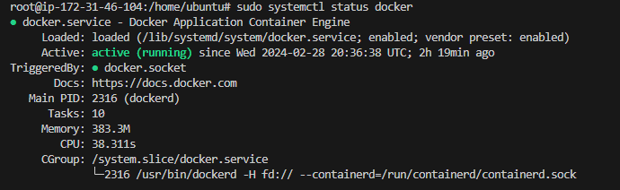

Create docker file:

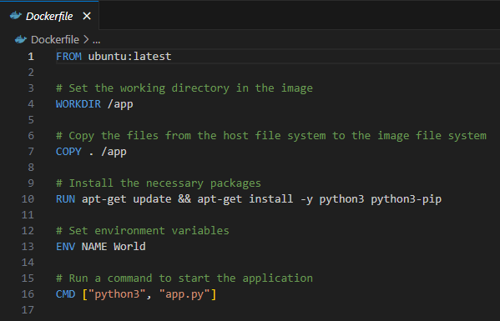

Create python app file:

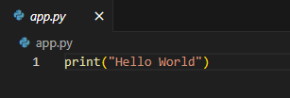

Place files in EC2 machine & initiate docker build:

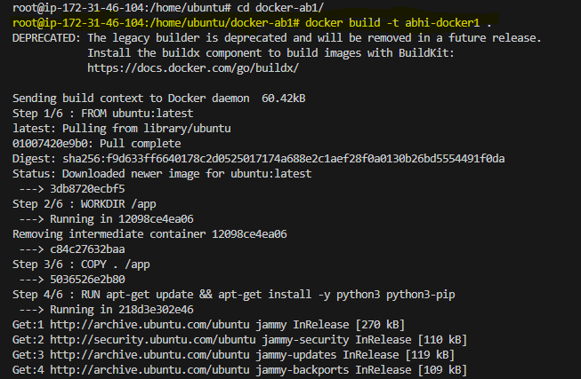

Connect to docker account:

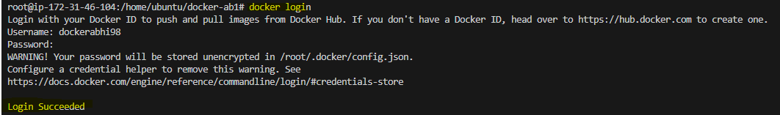

Push docker image:

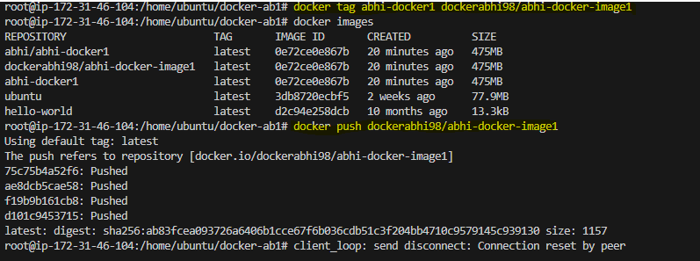

Check docker image in HUB:

